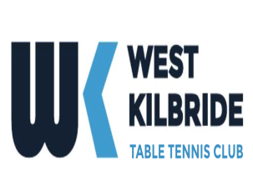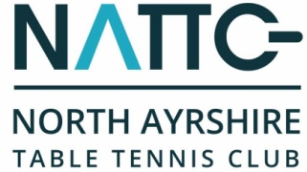

North Ayrshire Table Tennis Club - Golf Day 2018

North Ayrshire Table Tennis Club will be hosting their 2ND fundraising Golf Day in aid of their club's junior development programme.
The venue will be the beautiful parkland course - Largs Golf Club (Kelburn) on Friday 13th April 2018.

Shotgun start ..2pm
To book your team(s), please complete the following and return to Billy Main, 39 Jacks Road Saltcoats,Ayrshire KA21 5SH, or email; info@northayrshirettc.co.uk
I would like to support the NATTC Golf Day on Friday 13th April 2018.

Number of teams ___ at £200 per team. Total £_____
Contact Details

Contact Name
Team Name·
Address

Postcode
Telephone
Email
Payment Details
Total amount payable to North Ayrshire Table Tennis Club £_____

To confirm your entry a 50% deposit is required by 20th March and full payment by 1st April.

I enclose a cheque for £______ made payable to North Ayrshire Table Tennis Club

Payment can also be made by on line transfer to :

Name of Account…….NORTH AYRSHIRE TABLE TENNIS CLUB
Sort Code……………..832702
Account No……………00246825

Please invoice me at the above address

Players names and respective handicaps to be sent by 7th April

Signature Date_______________

