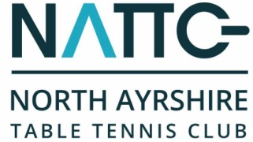

North Ayrshire Table Tennis Club - Golf Day 2017

North Ayrshire Table Tennis Club will be hosting their fundraising Golf Day in aid of their club's junior development programme.
The venue will be the beautiful parkland course - Largs Golf Club (Kelburn) on Friday 21st April 2017.
To book your team(s), please complete the following and return to Billy Main, 39 Jacks Road Saltcoats,Ayrshire KA21 5SH, or email; info@northayrshirettc.co.uk
I would like to support the NATTC Golf Day on Friday 21st April 2017.

Number of teams ___ at £200 per team. Total £_____
Contact Details

Contact Name
Team Name·
Address

Postcode
Telephone
Email

Payment Details
Total amount payable to North Ayrshire Table Tennis Club £_____

1. 50% deposit is required by 10th March to confirm your entry and full payment by 7th April

2. I enclose a cheque for £______ made payable to North Ayrshire Table Tennis Club

3. Please invoice me at the above address

4. Players names and respective handicaps to be sent by 7th April

Signature Date_______________

